Day 9 – 28/07/2026

Spring Framework - Quick revise

Task 1:
Can you create a Maven based spring project using ide.. To print a welcome..note
package com.example;
import org.springframework.context.ApplicationContext;
import org.springframework.context.annotation.AnnotationConfigApplicationContext;
public class MainApp {
public static void main(String[] args) {
ApplicationContext context =
new AnnotationConfigApplicationContext(AppConfig.class);
WelcomeBean wb = context.getBean(WelcomeBean.class);
wb.showMessage();
}
}

package com.example;
import org.springframework.context.annotation.Bean;
import org.springframework.context.annotation.Configuration;
@Configuration
public class AppConfig {
@Bean
public WelcomeBean welcomeBean() {
return new WelcomeBean();
}
}

package com.example;
public class WelcomeBean {
public void showMessage() {
System.out.println("Welcome to Spring Maven Project!");
}
}

Task 2:
Now create a POJO class for student so that can be managed as a spring bean
Student.java
package com.example;
public class Student {
private int id;
private String name;
private String course;
// Default Constructor
public Student() {
}
// Parameterized Constructor
public Student(int id, String name, String course) {
this.id = id;
this.name = name;
this.course = course;
}
// Getters and Setters
public int getId() {
return id;
}
public void setId(int id) {
this.id = id;
}
public String getName() {
return name;
}
public void setName(String name) {
this.name = name;
}
public String getCourse() {
return course;
}
public void setCourse(String course) {
this.course = course;
}
// Method to display student details
public void display() {
System.out.println("Student ID : " + id);
System.out.println("Student Name : " + name);
System.out.println("Course : " + course);
}
}

AppConfig.java
package com.example;
import org.springframework.context.annotation.Bean;
import org.springframework.context.annotation.Configuration;
@Configuration
public class AppConfig {
@Bean
public Student student() {
Student s = new Student();
s.setId(101);
s.setName("Vicky");
s.setCourse("Java Full Stack");
return s;
}
}

Main class
package com.example;
import org.springframework.context.ApplicationContext;
import org.springframework.context.annotation.AnnotationConfigApplicationContext;
public class MainApp {
public static void main(String[] args) {
ApplicationContext context =
new AnnotationConfigApplicationContext(AppConfig.class);
Student student = context.getBean(Student.class);
student.display();
}
}

Task 3:
Configure the above Student bean in the bean-factory-demo.xml file.
That means you need to configure the Student bean in the XML file so the BeanFactory knows how to create it.
And create a main class and run it.. A pictorial rep of the scenario is given below
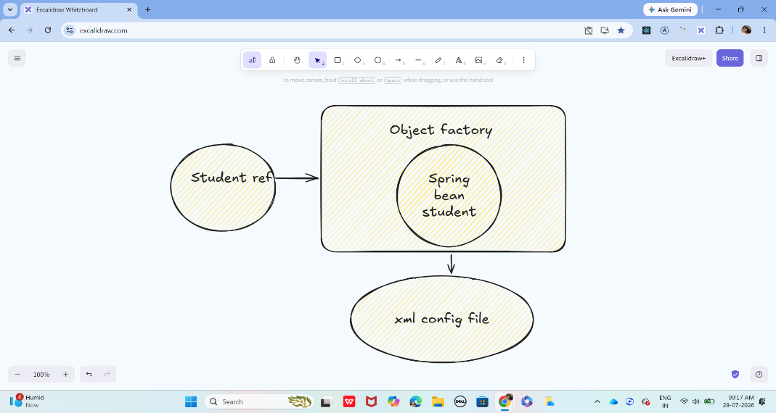
Pom.xml
<project xmlns="http://maven.apache.org/POM/4.0.0"
xmlns:xsi="http://www.w3.org/2001/XMLSchema-instance"
xsi:schemaLocation="http://maven.apache.org/POM/4.0.0
https://maven.apache.org/xsd/maven-4.0.0.xsd">
<modelVersion>4.0.0</modelVersion>
<groupId>com.example</groupId>
<artifactId>SpringBeanFactoryDemo</artifactId>
<version>1.0</version>
<dependencies>
<dependency>
<groupId>org.springframework</groupId>
<artifactId>spring-context</artifactId>
<version>5.3.30</version>
</dependency>
</dependencies>
</project>

Student.java
package com.example;
public class Student {
private int id;
private String name;
private String course;
public Student() {
}
public int getId() {
return id;
}
public void setId(int id) {
this.id = id;
}
public String getName() {
return name;
}
public void setName(String name) {
this.name = name;
}
public String getCourse() {
return course;
}
public void setCourse(String course) {
this.course = course;
}
public void display() {
System.out.println("Student ID : " + id);
System.out.println("Student Name : " + name);
System.out.println("Course : " + course);
}
}

src/main/resources
<?xml version="1.0" encoding="UTF-8"?>
<beans xmlns="http://www.springframework.org/schema/beans"
xmlns:xsi="http://www.w3.org/2001/XMLSchema-instance"
xsi:schemaLocation="
http://www.springframework.org/schema/beans
https://www.springframework.org/schema/beans/spring-beans.xsd">
<bean id="student"
class="com.example.Student">
<property name="id" value="101"/>
<property name="name" value="Vicky"/>
<property name="course" value="Java Full Stack"/>
</bean>
</beans>

MainApp.java
package com.example;
import org.springframework.beans.factory.BeanFactory;
import org.springframework.beans.factory.xml.XmlBeanFactory;
import org.springframework.core.io.ClassPathResource;
import org.springframework.core.io.Resource;
@SuppressWarnings("deprecation")
public class MainApp {
public static void main(String[] args) {
Resource resource =
new ClassPathResource("bean-factory-demo.xml");
BeanFactory factory =
new XmlBeanFactory(resource);
Student student =
(Student) factory.getBean("student");
student.display();
}
}

Task 4:
Can you explain application context with the syntax..
ApplicationContext is an advanced container in the Spring Framework that creates, configures, and manages Spring beans. It is a sub-interface of BeanFactory and provides additional enterprise features.
Syntax -
ApplicationContext context = new ClassPathXmlApplicationContext("bean-factory-demo.xml");
Explanation
- ApplicationContext → Interface provided by Spring.
- context → Reference variable.
- ClassPathXmlApplicationContext → Implementation class that loads the XML configuration file from the classpath.
- "bean-factory-demo.xml" → XML file containing bean definitions.

Task 5:
Why use application context .. plz list some uses?
ApplicationContext is preferred over BeanFactory because it provides many additional features.
Feature | Description
1. Pre-instantiates singleton beans | Creates singleton beans when the container starts, reducing runtime delays.
2. Dependency Injection | Automatically injects dependencies between objects.
3. Internationalization (i18n) | Supports multiple languages using message resource bundles.
4. Event Handling | Allows publishing and listening to application events.
5. Resource Loading | Easily loads resources such as XML files, properties files, and images.
6. Bean Lifecycle Management | Handles bean initialization and destruction callbacks.
7. Annotation Support | Supports annotations like @Component, @Autowired, @Service, @Repository, and @Configuration.
8. AOP Integration | Supports Aspect-Oriented Programming for logging, security, and transaction management.
9. Environment & Properties | Reads configuration from properties or YAML files.
10. Better than BeanFactory | Includes all BeanFactory features plus many enterprise-level capabilities.

Task 6:
What are features of Spring Framework .. list them with 1 or 2 lines explanation?
1. Lightweight
Spring is lightweight because it uses simple Java objects (POJOs) and has a small runtime footprint.
2. Inversion of Control (IoC)
Spring creates and manages objects instead of the programmer creating them using the new keyword.
3. Dependency Injection (DI)
Dependencies are injected automatically into objects, resulting in loosely coupled components.
4. Aspect-Oriented Programming (AOP)
Separates cross-cutting concerns like logging, security, and transaction management from the business logic.
5. Modular Architecture
Spring is divided into independent modules (Core, MVC, JDBC, ORM, Security, etc.), allowing you to use only what your application requires.
6. MVC Framework
Spring MVC helps build web applications using the Model-View-Controller design pattern, making applications easier to organize and maintain.
7. Transaction Management
Spring provides declarative transaction management, ensuring database operations are committed or rolled back correctly.
8. Integration Support
Spring integrates easily with technologies such as Hibernate, JPA, JDBC, Maven, REST APIs, and various databases.
9. Exception Handling
Spring provides a consistent exception hierarchy and simplifies handling application exceptions.
10. Testing Support
Spring offers excellent support for unit testing and integration testing with JUnit and Mockito.

Task 7:
Why do you thunk w e use spring framework.. Advantages list them down?
1. Reduces Boilerplate Code
Spring minimizes repetitive coding by providing built-in features and configuration support.
2. Loose Coupling
Objects are less dependent on each other because Spring manages dependencies through Dependency Injection.
3. Easy Maintenance
A modular architecture makes applications easier to update, debug, and maintain.
4. Better Testability
Applications are easier to test because dependencies can be mocked or injected during testing.
5. Flexible Configuration
Spring supports XML configuration, Java-based configuration, and annotations.
6. Easy Integration
Works seamlessly with Hibernate, JPA, JDBC, REST services, Maven, and many other frameworks.
7. Improved Productivity
Developers can focus on business logic instead of infrastructure code.
8. Scalable Applications
Spring is suitable for small, medium, and enterprise-scale applications.
9. Strong Community Support
Spring has extensive documentation, community support, and frequent updates.
10. Open Source
Spring is free to use and continuously improved by a large open-source community.

Task 8:
What do you understand by IOC? Explain with diagram..
Inversion of Control (IoC) is a design principle in which the responsibility of creating and managing objects is transferred from the programmer to the Spring IoC Container.
Without Spring, the programmer creates objects using the new keyword.
With Spring, the IoC container creates, configures, and manages the objects (beans).
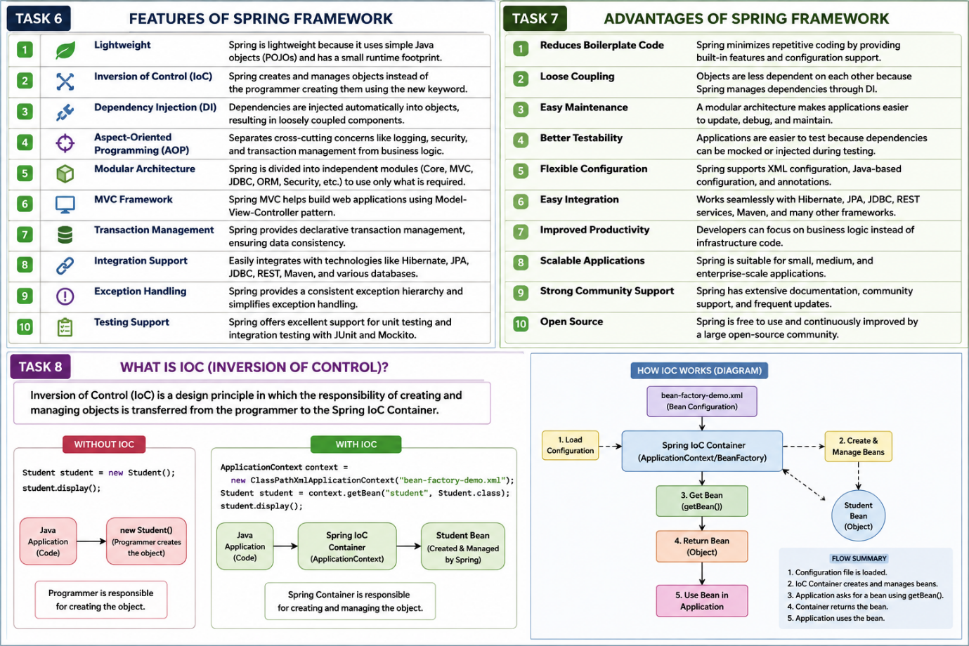

Task 9:
How many types of IOC do you have in spring?
What are they with explanation
1. Dependency Injection (DI)
Dependency Injection is the most commonly used type of IoC. The Spring container creates the object and injects its required dependencies automatically instead of the programmer creating them manually.
2. Dependency Lookup (DL)
In Dependency Lookup, the application explicitly asks the Spring container for an object whenever it is needed by calling getBean().
Dependency Injection (DI) – Spring injects dependencies automatically.
Dependency Lookup (DL) – The application retrieves beans from the container using getBean().

Task 10:
What is DI in spring?
Dependency Injection (DI) is a design pattern in which the Spring IoC container creates objects and injects their required dependencies automatically instead of the programmer creating them manually.
A dependency is an object that another object needs to perform its work.

Task 11:
How many types of DI do we have?
Explain
1. Constructor Injection
Dependencies are provided through the constructor when the object is created.
2. Setter Injection
Dependencies are injected using setter methods after the object is created.
3. Field Injection
Field Injection is a type of Dependency Injection where Spring injects the dependency directly into a class field using the @Autowired annotation. You do not need a constructor or setter method.

Task 12:
What is Spring Application Configuration?
Spring Application Configuration is the process of telling the Spring IoC container how to create, configure, and manage beans (objects) in an application.
It specifies:
- Which classes should be managed as beans.
- How beans are created.
- How dependencies are injected.
- Bean scope and lifecycle.

Task 13:
What are the different ways to configure spring applications?
1. XML-Based Configuration
Bean definitions are written in an XML file.
Example:
<bean id="student" class="com.example.Student"/>
2. Annotation-Based Configuration
Beans are configured using annotations.
Common annotations:
- @Component
- @Service
- @Repository
- @Controller
- @Autowired
Example:
@Component
public class Student {

}
3. Java-Based Configuration
Configuration is written in Java classes using @Configuration and @Bean.
Example:
@Configuration
public class AppConfig {

@Bean
public Student student() {
return new Student();
}
}

Task 14:
Why we need spring application copnfiguration?
Spring Application Configuration is required because it tells the Spring container how to manage the application.
Reasons for Using Spring Application Configuration
1. Bean Creation
Defines which classes should be created as Spring beans.
2. Dependency Injection
Specifies how dependencies should be injected into beans.
3. Centralized Configuration
Keeps all application configuration in one place, making it easier to manage.
4. Loose Coupling
Objects are managed by Spring instead of being created manually using the new keyword.
5. Bean Lifecycle Management
Spring controls bean creation, initialization, and destruction.
6. Easy Maintenance
Configuration changes can often be made without modifying business logic.
7. Better Scalability
Applications become easier to extend and maintain as they grow.

Task 15:
What are the difference ways to configure spring application?
Spring applications can be configured in three ways.
1. XML-Based Configuration
In this approach, bean definitions are written in an XML file.
2. Annotation-Based Configuration
Beans are configured using annotations.
Common annotations:
- @Component
- @Service
- @Repository
- @Controller
- @Autowired
3. Java-Based Configuration
Configuration is done using Java classes with @Configuration and @Bean.

Task 16:
What is bean scope .. give different scopes with description
Spring provides 6 bean scopes.
1. Singleton (Default)
- Only one object is created for the entire Spring container.
- Every request returns the same object.
2. Prototype
- A new object is created every time the bean is requested.
3. Request
- One bean instance is created for each HTTP request.
Use Case: Spring Web MVC applications.
4. Session
- One bean instance is created for each user session.
Use Case: Shopping cart, user profile.
5. Application
- One bean instance is shared across the entire web application.
Use Case: Application-wide configuration.
6. WebSocket
- One bean instance is created for each WebSocket session.
Use Case: Real-time chat applications.

Task 17:
What is autowiring in spring?
Autowiring is a feature of Spring that automatically injects the required dependencies into a bean without explicitly configuring them in XML or Java code.
It reduces manual configuration and simplifies Dependency Injection.
Example
Address.java
@Component
public class Address {

}
Student.java
@Component
public class Student {

@Autowired
private Address address;

}

Task 18:
What are diff ways of autowiring?
1. Autowiring by Name (byName)
- Spring matches the bean name with the property name.
- If both names match, the dependency is injected automatically.
Example
<bean id="address" class="com.example.Address"/>

<bean id="student" class="com.example.Student" autowire="byName"/>
2. Autowiring by Type (byType)
- Spring matches the dependency based on its data type.
- If only one bean of that type exists, it is injected.
Example
<bean id="address" class="com.example.Address"/>

<bean id="student" class="com.example.Student" autowire="byType"/>
3. Constructor Autowiring (constructor)
- Spring injects dependencies through the constructor.
Example
<bean id="address" class="com.example.Address"/>

<bean id="student" class="com.example.Student" autowire="constructor"/>
4. Annotation-Based Autowiring (@Autowired)
- Spring automatically injects dependencies using the @Autowired annotation.
- This is the most commonly used approach in Spring Boot.
Example
@Component
public class Student {

@Autowired
private Address address;

}

Task 19:
What is diff between a normal java object and Spring bean?
Normal Java Object | Spring Bean
Created using the new keyword. | Created and managed by the Spring IoC container.
Lifecycle is managed by the programmer. | Lifecycle is managed by Spring.
Dependencies are created manually. | Dependencies are injected automatically by Spring.
Not managed by the Spring container. | Managed by the Spring container.
Suitable for simple Java programs. | Used in Spring applications.

Task 20:
What is diff between @ component and @ bean
@Component | @Bean
Applied on a class. | Applied on a method.
Spring automatically detects it during component scanning. | Spring creates the bean from the method's return value.
Used for classes that you own. | Used when configuring third-party or external classes, or when custom bean creation is needed.
Requires @ComponentScan. | Declared inside a class annotated with @Configuration.
Automatic bean registration. | Manual bean registration.

Task 21
Question:
A different way to create an application using https://start.spring.io/ . What is it?
Answer:
Spring Initializr (https://start.spring.io/) is an online tool provided by Spring to quickly create a Spring Boot project.
Features:
- Generates Spring Boot project structure automatically.
- Allows selection of:
  - Project (Maven/Gradle)
  - Java Version
  - Spring Boot Version
  - Dependencies (Web, JPA, Security, etc.)
- Downloads a ready-to-use project as a ZIP file.
- Eliminates manual project setup.
Steps:
- Open https://start.spring.io/
- Select Maven/Gradle.
- Enter Group and Artifact name.
- Select dependencies.
- Click Generate.
- Import project into Eclipse/IntelliJ/STS.

Task 22
Question:
Using Spring Initializer create an Employee class, AppConfig file, and Main class and see how it works.
public class Employee {

private int empId;
private String empName;

public Employee() {
}

public Employee(int empId, String empName) {
this.empId = empId;
this.empName = empName;
}

public void display() {
System.out.println("Employee Id : " + empId);
System.out.println("Employee Name : " + empName);
}
}

import org.springframework.context.annotation.Bean;
import org.springframework.context.annotation.Configuration;

@Configuration
public class AppConfig {

@Bean
public Employee employee() {
return new Employee(101, "Pavan");
}
}

import org.springframework.context.ApplicationContext;
import org.springframework.context.annotation.AnnotationConfigApplicationContext;

public class Main {

public static void main(String[] args) {

ApplicationContext context =
new AnnotationConfigApplicationContext(AppConfig.class);

Employee emp = context.getBean(Employee.class);

emp.display();
}
}

Task 23
Question:
Give one line about Spring Annotations.
Answer:
@Bean
Creates and registers a Spring Bean in the IoC container.
@Controller
Marks a class as a Spring MVC Controller.
@Value
Injects values from properties files or expressions.
@ComponentScan
Scans packages for Spring-managed components.
@Configuration
Indicates that a class contains bean definitions.
@Service
Marks a class as a Service layer component.
@Repository
Marks a class as a DAO/Persistence component.
@Qualifier
Used to specify which bean should be injected when multiple beans exist.
@Required
Indicates a required bean property must be configured. (Deprecated in newer Spring versions.)
@Component
Marks a class as a Spring-managed component.
@Autowired
Automatically injects dependencies by type.
@Scope
Defines bean scope such as singleton or prototype.

Task 24
Question:
What are the features of Spring Boot?
Answer:
- Auto Configuration.
- Embedded Tomcat/Jetty/Undertow.
- Starter Dependencies.
- Production Ready Features.
- Spring Actuator Support.
- Minimal Configuration.
- Rapid Application Development.
- Microservices Support.
- Externalized Configuration.
- REST API Development Support.

Task 25
Question:
What are the advantages of Spring Boot?
Answer:
- Reduces development time.
- Eliminates complex XML configuration.
- Embedded web servers included.
- Easy dependency management.
- Faster project setup.
- Production-ready monitoring.
- Better microservice support.
- Easy deployment.
- Simplified testing.
- Convention over configuration approach.

Task 26
Question:
What are the key components of Spring Boot?
Answer:
1. Spring Boot Starters
Predefined dependency packages.
2. Auto Configuration
Automatically configures application components.
3. Spring Boot Actuator
Provides monitoring and management endpoints.
4. Spring Boot CLI
Runs Spring applications from command line.
5. Embedded Servers
Tomcat, Jetty, Undertow.
6. SpringApplication Class
Used to bootstrap Spring Boot applications.
7. Externalized Configuration
Configuration through application.properties or application.yml.
8. Spring Data
Database access support.

Task 27
Question:
Why Spring Boot over Spring?
Spring | Spring Boot
Requires extensive configuration | Minimal configuration
External server required | Embedded server available
More XML setup | Annotation based
Manual dependency setup | Starter dependencies
Complex project setup | Quick project setup
Longer development time | Faster development

Task 28
Question:
Explain the internal working of Spring Boot.
Answer:
Step 1
Program execution starts from main() method.
Step 2
SpringApplication.run() is called.
Step 3
Spring Boot creates an ApplicationContext.
Step 4
Component Scanning starts.
Step 5
Beans annotated with:
- @Component
- @Service
- @Repository
- @Controller
are detected and registered.
Step 6
Auto Configuration configures components automatically.
Step 7
Embedded Tomcat server starts.
Step 8
DispatcherServlet gets initialized.
Step 9
REST Controllers and request mappings are registered.
Step 10
Application becomes ready to accept requests.

Task 29
Question:
List starter dependencies of Spring Boot.
spring-boot-starter
spring-boot-starter-web
spring-boot-starter-data-jpa
spring-boot-starter-jdbc
spring-boot-starter-test
spring-boot-starter-security
spring-boot-starter-thymeleaf
spring-boot-starter-actuator

spring-boot-starter-websocket
Task 30
Question:
What is the internal working of the following code?

import org.springframework.boot.SpringApplication;
import org.springframework.boot.autoconfigure.SpringBootApplication;

@SpringBootApplication
public class MyApplication {

public static void main(String[] args) {
SpringApplication.run(MyApplication.class, args);
}
}
JVM starts execution from main().
Spring Boot creates a SpringApplication object.
ApplicationContext is created.
@SpringBootApplication is processed.
Component scanning starts.

@Component
@Service
@Repository
@Controller
@RestController
and registers them as beans.

Auto Configuration configures:
- DataSource
- DispatcherServlet
- Jackson
- Security
- JPA
automatically.
Embedded Tomcat server starts.
DispatcherServlet is registered.
Request mappings are loaded.
Application becomes ready to serve requests.
Task 31
Question:
What is the syntax to change the port of the embedded Tomcat server in Spring Boot?
Answer:
application.properties
server.port=9090
application.yml
YAML
1
server:
2
port: 9090
Show more lines
Programmatically
@SpringBootApplication
public class MyApplication {

public static void main(String[] args) {

SpringApplication app = new SpringApplication(MyApplication.class);

app.setDefaultProperties(
Collections.singletonMap("server.port", "9090")
);

app.run(args);
}
}

